**ENVIRONMENTAL MANAGEMENT PROGRAMME**

MASA NGWEDI 400 kV AND 765kV TRANSMISSION LINES

**Avifauna: Report No 2**

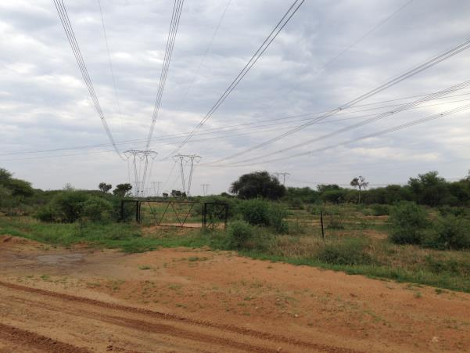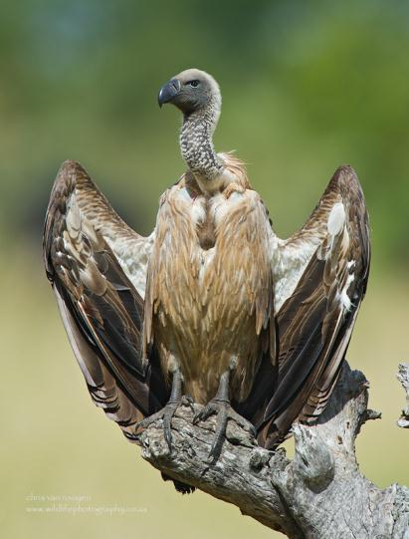

**January 2014**

**Prepared by:**

Chris van Rooyen Consulting

30 Roosevelt Street

Robindale

Randburg

2194

South Africa

Tel: +27824549570

Email: vanrooyen.chris@gmail.com

**Prepared for:**

Senkosi Consulting

**Chris van Rooyen**

Chris has seventeen years’ experience in the management of wildlife interactions with electricity infrastructure. He was head of the Eskom-Endangered Wildlife Trust (EWT) Strategic Partnership from 1996 to 2007, which has received international acclaim as a model of co-operative management between industry and natural resource conservation.  He is an acknowledged global expert in this field and has worked in South Africa, Namibia, Botswana, Lesotho, New Zealand, Texas, New Mexico and Florida. Chris also has extensive project management experience and has received several management awards from Eskom for his work in the Eskom-EWT Strategic Partnership. He is the author of 15 academic papers (some with co-authors), co-author of two book chapters and several research reports. He has been involved as ornithological consultant in more than 100 power line and 25 wind generation projects. Chris is also co-author of the Best Practice for Avian Monitoring and Impact Mitigation at Wind Development Sites in Southern Africa, which is currently (2013) accepted as the industry standard. Chris also works outside the electricity industry and had done a wide range of bird impact assessment studies associated with various residential and industrial developments.

**Albert Froneman (Pr.Sci.Nat)**

Albert has an M. Sc. in Conservation Biology from the University of Cape Town, and started his career in the natural sciences as a Geographic Information Systems (GIS) specialist at Council for Scientific and Industrial Research (CSIR). He is a registered Professional Natural Scientist in the field of zoological science with the South African Council of Natural Scientific Professionals (SACNASP). In 1998, he joined the Endangered Wildlife Trust where he headed up the Airports Company South Africa – EWT Strategic Partnership, a position he held until he resigned in 2008 to work as a private ornithological consultant. Albert’s specialist field is the management of wildlife, especially bird related hazards at airports. His expertise is recognized internationally; in 2005 he was elected as Vice Chairman of the International Bird Strike Committee. Since 2010, Albert has worked closely with Chris van Rooyen in developing a protocol for pre-construction monitoring at wind energy facilities, and they are currently jointly coordinating pre-construction monitoring programmes at several wind farm facilities. Albert also works outside the electricity industry and had done a wide range of bird impact assessment studies associated with various residential and industrial developments.

**DECLARATION OF INDEPENDENCE**

I, Chris van Rooyen as duly authorised representative of Chris van Rooyen Consulting, and working under the supervision of and in association with Albert Froneman (SACNASP Zoological Science Registration number 400177/09) as stipulated by the Natural Scientific Professions Act 27 of 2003, hereby confirm my independence (as well as that of Chris van Rooyen Consulting) as a specialist and declare that neither I nor Chris van Rooyen Consulting have any interest, be it business, financial, personal or other, in any proposed activity, application or appeal in respect of which Envirolution Consulting was appointed as environmental assessment practitioner in terms of the National Environmental Management Act, 1998 (Act No. 107 of 1998), other than fair remuneration for worked performed, specifically in connection with the EMPr for the Masa – Ngwedi 765kV transmission line.

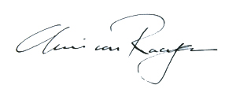

___________________________

Full Name: Chris van Rooyen

1. **BACKGROUND**

This avifaunal “walk-through” report forms part of the Environmental Management Programme Report (EMPr) for the second section (approximately 40km) of the Masa - Ngwedi 400kV and 765kV transmission lines. Figure 1 below is a satellite image of the general location of the second section of the two alignments:

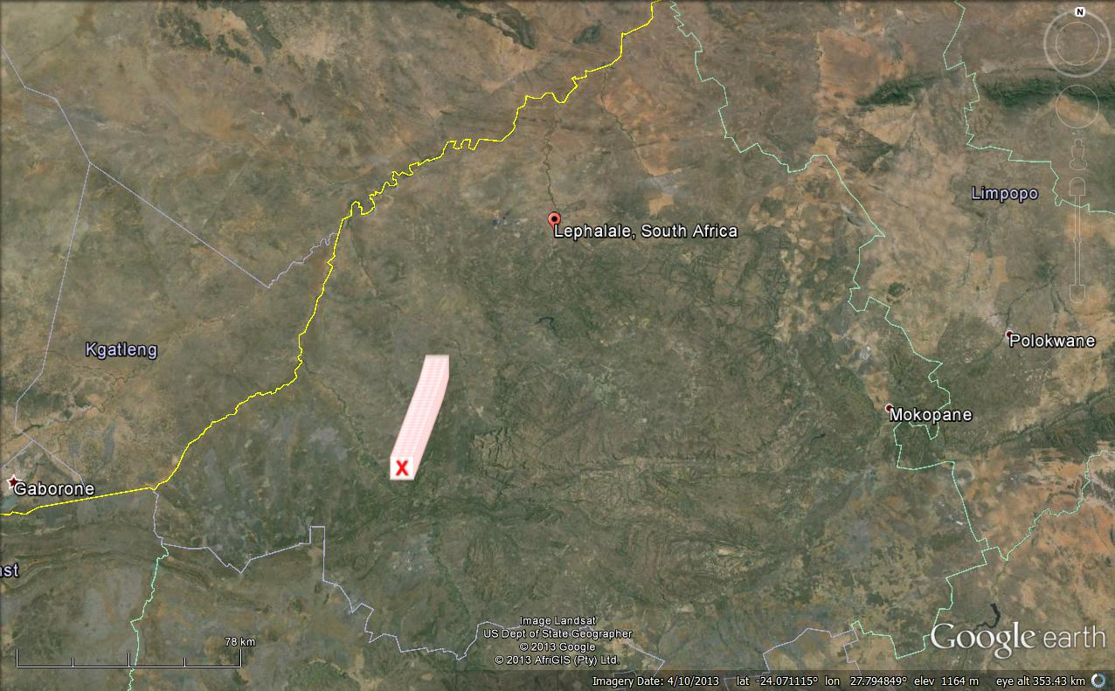

Figure 1: Satellite image of the general location of the second section of the Masa – Ngwedi 400kV and 765kV transmission lines (white line).

A bird impact assessment study for six proposed Masa – Selomo 765kV lines, which included the Masa – Ngwedi lines, was completed in June 2009 (one line was subsequently downgraded to 400kV), and this “walk-through” report should be read in conjunction with the 2009 bird impact assessment study (Van Rooyen 2009). The impact assessment study found that the construction of the proposed transmission lines will have certain impacts of varying intensity and significance on birds in the study area. These impacts are:

* Habitat destruction, specifically vegetation clearing, resulting in the transformation of the habitat, making it unsuitable breeding habitat for specific species;
* Disturbance caused by the construction operations; and
* Direct mortality caused by collisions with the earth wire of the proposed lines.

The bird impact assessment study also concluded that from a **strictly avian** **transmission line impact** perspective, the impacts of the proposed power lines in the portion of the study area that falls within the woodland biome (which is where the second section is located) will not be particularly significant, except in a few specific instances. The reasons are the following:

* The vast majority of the study area comprises natural woodland. This habitat type does not support many species that are typically **directly** threatened by transmission lines through collision with the earth wire. Although collisions can happen here, it is likely to be few and far between, and associated with very specific circumstances.
* The areas where collisions are most likely to take place are restricted to very specific habitat that can relatively easily be identified.
* The habitat transformation that will take place in the servitudes will not preclude any bird species from still foraging in those areas, except some of the smaller, non-threatened woodland species.
* The disturbance that will be caused by the construction activities will be temporary and should not lead to species being permanently displaced from the area. However, in the case of large, sensitive species, particularly large raptors and vultures, this might lead to permanent displacement.
* The transmission lines hold no electrocution risks for the large raptors and vultures.

1. **TERMS OF REFERENCE**

The terms of reference for this report are as follows:

* To indicate specific mitigation measures that need to be implemented to address potential impacts on avifauna associated with the construction of the Masa – Ngwedi 400kV and 765kV transmission lines. The report deals with the Section 2: Turfpan to Paarl (approx. 39km); from towers 95 - 179 for the 765kV power line and from towers 97 to 175 for the 400kV power line.

1. **ASSUMPTIONS AND LIMITATIONS**

* The tower positions and tower numbers for the authorised 400kV and 765kV lines were obtained from Eskom via Senkosi Consulting. It is assumed that these positions are correct and will not be changed again prior to the construction of the lines.

1. **METHODS**

* Potential high risk areas along the alignments were identified on Google Earth high resolution satellite imagery, specifically areas where there could be a higher collision risk due to specific habitat being present.
* These identified high risk areas were investigated on foot and with a vehicle to establish the exact nature of the habitat on the ground.
* General spot checks were performed in the servitudes in order to gain a general impression of the habitat.
* An interview was conducted with Mr Albi Götsche from Environment Research Consulting who physically walked the whole alignment to identify protected tree species, who confirmed that no large raptor nests were present in the servitudes.

1. **IMPACT MITIGATION**

**5.1 Habitat destruction**

The vegetation clearing should be restricted to what is absolutely necessary, in order to minimize the impact on the natural woodland habitat. Strict adherence to Eskom standards and specifications is required, specifically:

* Section 4 (Environmental) of the Transmission Specification: Transmission Line Towers and Line Construction Ref: TRMSCAAC1 rev 3 (revised March 2003), and
* Standard for Bush Clearance and Maintenance within Overhead Power line Servitudes Ref: ESKASABG3 rev 1 (revised May 2003)

**5.2 Disturbance**

Strict adherence to Eskom standards and specifications is required, specifically:

* Section 4 (Environmental) of the Transmission Specification: Transmission Line Towers and Line Construction Ref: TRMSCAAC1 rev 3 (revised March 2003), and
* Standard for Bush Clearance and Maintenance within Overhead Power line Servitudes Ref: ESKASABG3 rev 1 (revised May 2003)

Care should be taken not to disturb any large raptors or vulture species in or in the immediate vicinity of the servitude. If **an active nest** of such large breeding raptor or vulture is encountered, the construction work must be halted and the Environmental Control Officer (ECO) should be informed. The ECO must in turn inform the author and a mitigation strategy must be jointly devised to minimise the disturbance to the breeding birds.

**5.3 Collisions with the earthwire of the transmission lines**

The marking of the earth wire with anti-collision devices is a standard practice world-wide to mitigate for avian impacts. This measure has been proved to be reasonably successful in reducing collisions, with success rates of up to 60% reduction in mortality and even more documented (see Jenkins *et al.* 2010). There are several devices available in southern Africa for the marking of power lines. Some are dynamic devices (usually called bird flappers), and some are static. Both have advantages and disadvantages. Dynamic devices are thought to be very effective in reducing collisions as the birds presumably see them very well because of the movement that attracts their attention. The disadvantage of dynamic devices is that they are subject to extensive wear and tear, inevitably limiting the lifespan of the device. This has obvious cost implications if a line needs to be re-marked at intervals of a few years. No solution to that problem has been found to date and it must be accepted as a constraint.

Static devices are mechanically more durable because they lack the element of wear and tear that moving parts inevitably have. In one study in South Africa, static devices, particularly the so called Bird Flight Diverter (also known as the BFD) has had limited success (Anderson 2001). However, there are many studies that prove that marking a line with PVC spiral type Bird Flight Diverters (BFD’s) can reduce the mortality rates by at least 60% (Alonso & Alonso 1999; Koops & De Jong 1982; Jenkins *et al.* 2010). Beaulaurier (1981) summarised the results of 17 studies that involved the marking of earth wires and found an average reduction in mortality of 45%. Koops and De Jong (1982) found that the spacing of the spirals were critical in reducing the mortality rates - mortality rates are reduced up to 86% with a spacing of 5 metres, whereas using the same devices at 10 metre intervals only reduces the mortality by 57%.

The proposed device to be used is the Double Loop Bird Flight Diverter. **The devices should be staggered 10 metres apart on the earth wires, alternating black and white or black and yellow**.

The sections of line that need to be marked with BFD’s are indicated in Appendix A and Appendix B. The type of BFD to be used is attached as Appendix C.

**6 REFERENCES**

* Alonso, J.A. & Alonso, C.A. 1999. Mitigation of bird collisions with transmission lines through groundwire marking. In: Birds and Power Lines Eds: M. Ferrer & G. F. E. Janss, Quercus, Madrid.
* Anderson, M.D. 2001. The effectiveness of two different marking devices to reduce large terrestrial bird collisions with overhead electricity cables in the eastern Karoo, South Africa. Draft report to Eskom Resources and Strategy Division. Johannesburg. South Africa.
* Beaulaurier, D.L. 1981. Mitigation of bird collisions with transmission lines. Bonneville Power Administration. U.S. Dept. of Energy.
* Koops, F.B.J. & De Jong, J. 1982. Vermindering van draadslachtoffers door markering van hoogspanningsleidingen in de omgeving van Heerenveen. Electrotechniek 60 (12): 641 – 646.
* Jenkins, A.R., Smallie, J.J. & Diamond, M. 2010. Avian collisions with power lines: a global review of causes and mitigation with a South African perspective. *Bird Conservation International* 20: 263-278.
* Van Rooyen, C.S. 2009. Masa – Selomo 765kV Bird Impact Assessment Study. Report to PBA International.

**APPENDIX A: MITIGATION TABLE MASA – NGWEDI 400KV**

|  |  |  |
| --- | --- | --- |
| **Masa-Ngwedi 400kV tower number** | **Comments** | **Mitigation** |
| 97 | No issues |  |
| 98 | Small farm dam between 98 and 99. May attract various water birds, and large raptors. | Small farm dam between 98 and 99. Mark with BFD's |
| 99 | Small farm dam between 98 and 99. May attract various water birds, and large raptors. | Small farm dam between 98 and 99. Mark with BFD's |
| 100 | No issues | None |
| 101 | No issues | None |
| 102 | No issues | None |
| 103 | No issues | None |
| 104 | No issues | None |
| 105 | No issues | None |
| 106 | No issues | None |
| 107 | No issues | None |
| 108 | No issues | None |
| 109 | No issues | None |
| 110 | No issues | None |
| 111 | No issues | None |
| 112 | Open cleared area both sides of the line which may attract Kori Bustard, Secretarybird an Abdim’s Stork | Mark with BFDs between 112 and 115 |
| 113 | Open cleared area both sides of the line which may attract Kori Bustard, Secretarybird an Abdim’s Stork | Mark with BFDs between 112 and 115 |
| 114 | Open cleared area both sides of the line which may attract Kori Bustard, Secretarybird an Abdim’s Stork | Mark with BFDs between 112 and 115 |
| 115 | Open cleared area both sides of the line which may attract Kori Bustard, Secretarybird an Abdim’s Stork | Mark with BFDs between 112 and 115 |
| 116 | No issues | None |
| 117 | No issues | None |
| 118 | No issues | None |
| 119 | Open cleared area both sides of the line which may attract Kori Bustard, Secretarybird an Abdim’s Stork | Mark with BFDs between 119 and 121 |
| 120 | Open cleared area both sides of the line which may attract Kori Bustard, Secretarybird an Abdim’s Stork | Mark with BFDs between 119 and 121 |
| 121 | Open cleared area both sides of the line which may attract Kori Bustard, Secretarybird an Abdim’s Stork | Mark with BFDs between 119 and 121 |
| 122 | No issues | None |
| 123 | No issues | None |
| 124 | No issues | None |
| 125 | No issues | None |
| 126 | No issues | None |
| 127 | No issues | None |
| 128 | No issues | None |
| 129 | No issues | None |
| 130 | No issues | None |
| 131 | No issues | None |
| 132 | No issues | None |
| 133 | No issues | None |
| 134 | No issues | None |
| 135 | No issues | None |
| 136 | No issues | None |
| 137 | Small farm dam between 137 and 138. May attract various water birds, and large raptors. | Small farm dam between 137 and 138. Mark with BFD's |
| 138 | Small farm dam between 137 and 138. May attract various water birds, and large raptors. | Small farm dam between 137 and 138. Mark with BFD's |
| 139 | No issues | None |
| 140 | No issues | None |
| 141 | No issues | None |
| 142 | No issues | None |
| 143 | No issues | None |
| 144 | No issues | None |
| 145 | No issues | None |
| 146 | No issues | None |
| 147 | No issues | None |
| 148 | No issues | None |
| 149 | No issues | None |
| 150 | No issues | None |
| 151 | No issues | None |
| 152 | No issues | None |
| 153 | No issues | None |
| 154 | No issues | None |
| 155 | No issues | None |
| 156 | No issues | None |
| 157 | No issues | None |
| 158 | No issues | None |
| 159 | No issues | None |
| 160 | No issues | None |
| 161 | No issues | None |
| 162 | No issues | None |
| 163 | No issues | None |
| 164 | Small farm dam between 164 and 165. May attract various water birds, and large raptors. | Small farm dam between 164 and 165. Mark with BFD's |
| 165 | Small farm dam between 164 and 165. May attract various water birds, and large raptors. | Small farm dam between 164 and 165. Mark with BFD's |
| 166 | No issues | None |
| 167 | No issues | None |
| 168 | No issues | None |
| 169 | No issues | None |
| 170 | No issues | None |
| 171 | No issues | None |
| 172 | No issues | None |
| 173 | No issues | None |
| 174 | No issues | None |
| 175 | No issues | None |

**APPENDIX B: MITIGATION MASA – NGWEDI 765KV**

|  |  |  |
| --- | --- | --- |
| **Masa-Ngwedi 765kV tower number** | **Comments** | **Mitigation** |
| 95 | No issues |  |
| 96 | Small farm dam between 96 and 97. May attract various water birds, and large raptors. | Small farm dam between 96 and 97. Mark with BFD's |
| 97 | Small farm dam between 96 and 97. May attract various water birds, and large raptors. | Small farm dam between 96 and 97. Mark with BFD's |
| 98 | No issues | None |
| 99 | No issues | None |
| 100 | No issues | None |
| 101 | No issues | None |
| 102 | No issues | None |
| 103 | No issues | None |
| 104 | No issues | None |
| 105 | No issues | None |
| 106 | No issues | None |
| 107 | No issues | None |
| 108 | No issues | None |
| 109 | No issues | None |
| 110 | No issues | None |
| 111 | No issues | None |
| 112 | Open cleared area both sides of the line which may attract Kori Bustard, Secretarybird and Abdim’s Stork | Mark with BFDs between 112 and 114 |
| 113 | Open cleared area both sides of the line which may attract Kori Bustard, Secretarybird and Abdim’s Stork | Mark with BFDs between 112 and 114 |
| 114 | Open cleared area both sides of the line which may attract Kori Bustard, Secretarybird and Abdim’s Stork | Mark with BFDs between 112 and 114 |
| 115 | No issues | None |
| 116 | No issues | None |
| 117 | No issues | None |
| 118 | Open cleared area both sides of the line which may attract Kori Bustard, Secretarybird an Abdim’s Stork | Mark with BFDs between 118 and 120 |
| 119 | Open cleared area both sides of the line which may attract Kori Bustard, Secretarybird and Abdim’s Stork | Mark with BFDs between 118 and 120 |
| 120 | Open cleared area both sides of the line which may attract Kori Bustard, Secretarybird and Abdim’s Stork | Mark with BFDs between 118 and 120 |
| 121 | No issues | None |
| 122 | No issues | None |
| 123 | No issues | None |
| 124 | No issues | None |
| 125 | No issues | None |
| 126 | No issues | None |
| 127 | No issues | None |
| 128 | No issues | None |
| 129 | No issues | None |
| 130 | No issues | None |
| 131 | No issues | None |
| 132 | No issues | None |
| 133 | No issues | None |
| 134 | No issues | None |
| 135 | No issues | None |
| 136 | No issues | None |
| 137 | No issues | None |
| 138 | Small farm dam between 138 and 139. May attract various water birds, and large raptors. | Small farm dam between 138 and 139. Mark with BFD's |
| 139 | Small farm dam between 138 and 139. May attract various water birds, and large raptors. | Small farm dam between 138 and 139. Mark with BFD's |
| 140 | No issues | None |
| 141 | No issues | None |
| 142 | No issues | None |
| 143 | No issues | None |
| 144 | No issues | None |
| 145 | No issues | None |
| 146 | No issues | None |
| 147 | No issues | None |
| 148 | No issues | None |
| 149 | No issues | None |
| 150 | No issues | None |
| 151 | No issues | None |
| 152 | No issues | None |
| 153 | No issues | None |
| 154 | No issues | None |
| 155 | No issues | None |
| 156 | No issues | None |
| 157 | No issues | None |
| 158 | No issues | None |
| 159 | No issues | None |
| 160 | No issues | None |
| 161 | No issues | None |
| 162 | No issues | None |
| 163 | No issues | None |
| 164 | No issues | None |
| 165 | No issues | None |
| 166 | No issues | None |
| 167 | Small farm dam between 167 and 168. May attract various water birds, and large raptors. | Small farm dam between 167 and 168. Mark with BFD's |
| 168 | Small farm dam between 167 and 168. May attract various water birds, and large raptors. | Small farm dam between 167 and 168. Mark with BFD's |
| 169 | No issues | None |
| 170 | No issues | None |
| 171 | No issues | None |
| 172 | No issues | None |
| 173 | No issues | None |
| 174 | No issues | None |
| 175 | No issues | None |
| 176 | No issues | None |
| 177 | No issues | None |
| 178 | No issues | None |
| 179 | No issues | None |

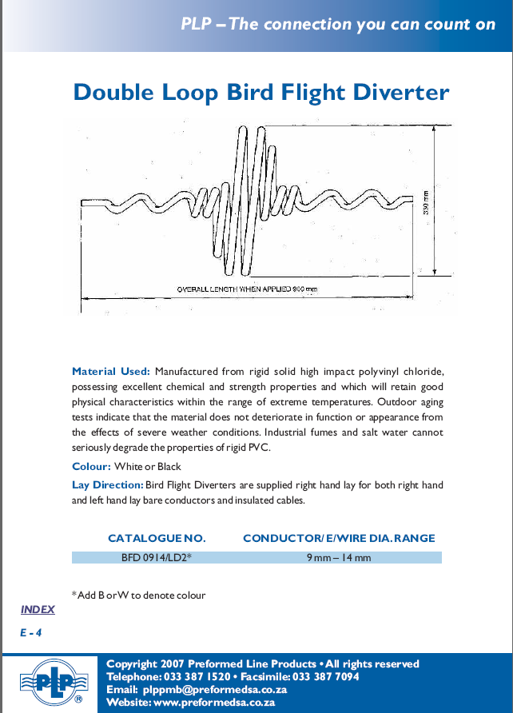

APPENDIX C

C